**LAPORAN PRAKTIKUM 11**

**PERCOBAAN 1**

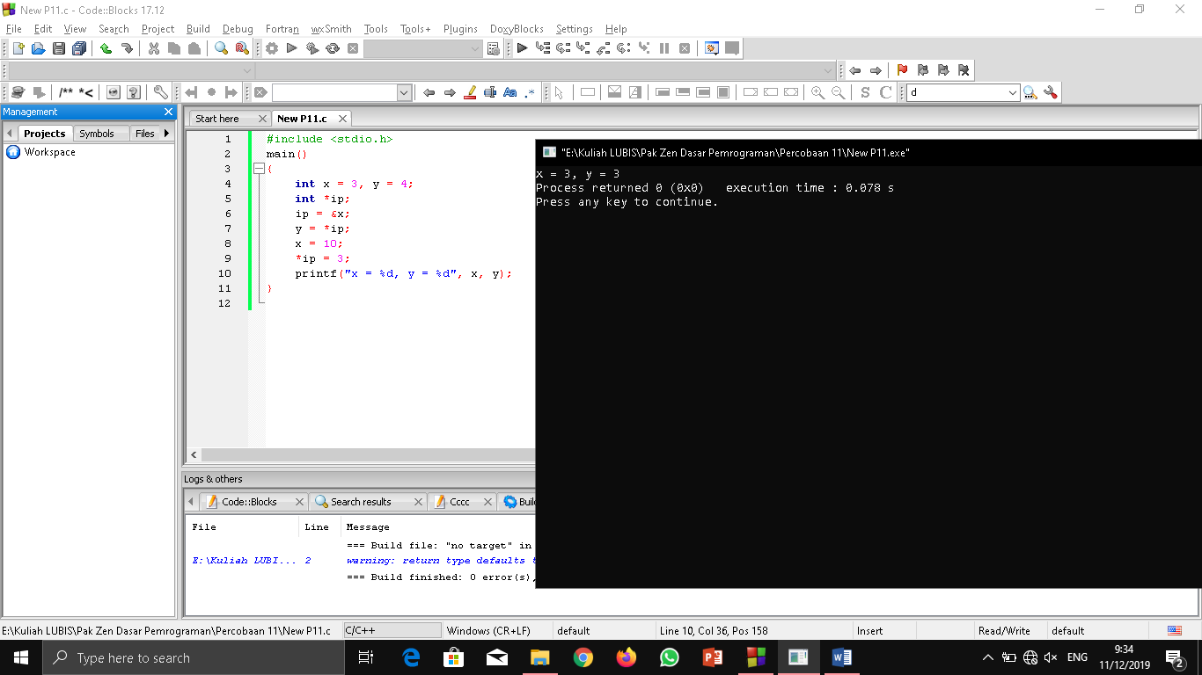

#include <stdio.h>

main()

{

int x = 3, y = 4;

int *ip;

ip = &x;

y = *ip;

x = 10;

*ip = 3;

printf("x = %d, y = %d", x, y);

}

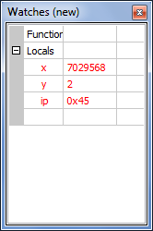 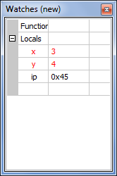 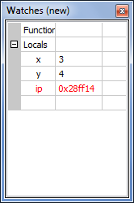

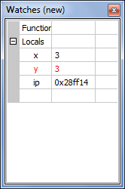 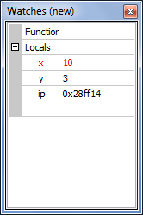 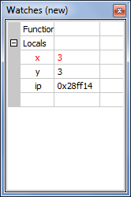

|  |  |  |
| --- | --- | --- |
| Alamat Memory | Nilai Variabel | Perintah |
| 1008 | Ip = 1000 | Ip = &x |
| 1004 | y = 4; y = 3 | y = *ip |
| 1000 | x = 3; x = 10; x = 3 | x = 10; *ip = 3 |

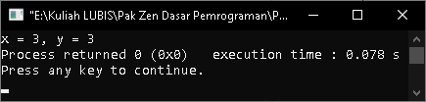

**PERCOBAAN 2**

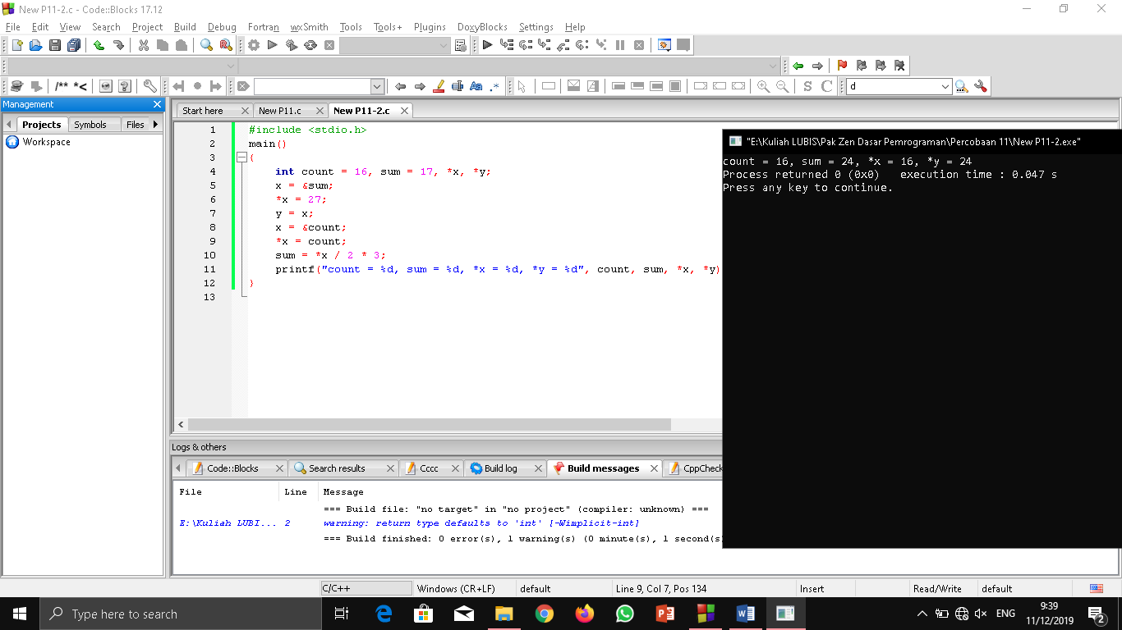

#include <stdio.h>

main()

{

int count = 16, sum = 17, *x, *y;

x = &sum;

*x = 27;

y = x;

x = &count;

*x = count;

sum = *x / 2 * 3;

printf("count = %d, sum = %d, *x = %d, *y = %d", count, sum, *x, *y);

}

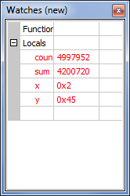 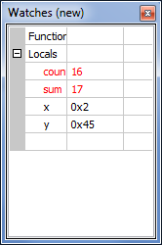 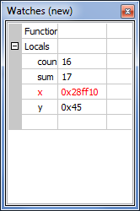

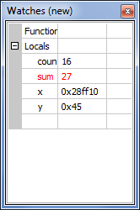 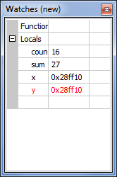 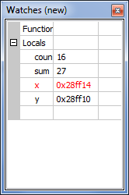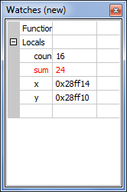

|  |  |  |
| --- | --- | --- |
| Alamat Memory | Nilai Variabel | Perintah |
| 1012 | y = 1004 | y = x |
| 1008 | x = 1004; x = 1000 | x = &sum; x = &count |
| 1004 | sum = 17; sum = 27; sum = 6 | *x = 27; sum = *x / 2 * 3 |
| 1000 | count = 16 |  |

